Free Youtube views for an unlimited number of your videos! Boost your video's popularity using their simple and free method! Or, buy Youtube views and other services here.

[ythunder.com](https://ythunder.com/) has free & open registrations.



As a platform, [YouTube](https://ythunder.com/) is synonymous with online videos. Every month, people across the world spend billions of hours in total watching videos on [YouTube](https://ythunder.com/). There are several people who have become stars thanks to the popularity of Free Youtube views：[ythunder.com](https://ythunder.com/)

content that they’ve created and put up on [YouTube](https://ythunder.com/).

Thanks to [YouTube](https://ythunder.com/), absolutely anyone with a camera can become a filmmaker and get millions of people to view their content.

As a result, there’s an almost-unlimited mount of content on [YouTube](https://ythunder.com/) competing for eyeballs. As a content creator, your video is successful only when a lot of people watch it. Therefore, the popularity of videos depends greatly on the number of people sharing it.

However, in order to share a video, people need to watch it first.

This brings us to the most important parameter for videos on [YouTube views](https://ythunder.com/). The number of  [YouTube views](https://ythunder.com/) on your content play a decisive role in ensuring that it becomes popular. As with any online asset, driving audiences to your Free Youtube views：[ythunder.com](https://ythunder.com/)

content is the most important thing.

Often, this is one of the biggest hurdles for content creators.

Therefore, in this article, we’ll tell you about the 10 ways to increase [YouTube views](https://ythunder.com/) for your video content:

* **Use the right titles**

Often, video creators use titles that do not adequately describe their video. As a result, these videos are ignored by audiences as the title tells them nothing about what the video contains. Therefore, it is very important to use a title that describes your video perfectly.

Moreover, by using the right keywords in your title can help ensure that viewers see your video when they search using specific terms.

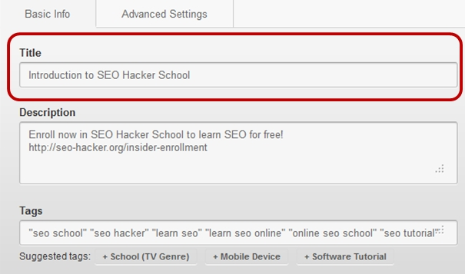

* **Deploy keywords and meta-tags**

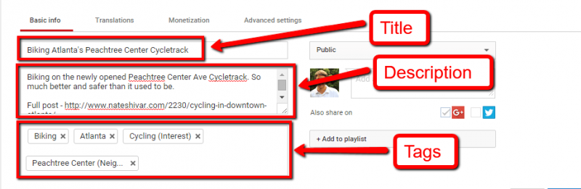

[YouTube](https://ythunder.com/) gives a moderate amount of weightage to keywords when used in your video description.

Moreover, perfect meta tags help To boost  [YouTube](https://ythunder.com/) algorithm in optimizing your video in search results. Therefore, ensure that you write a great concise description of your video and use the right meta tags.

* **Content ought to be relevant and topical**

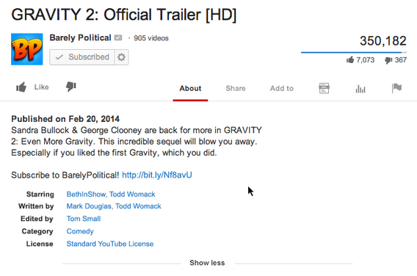

Every day, there’s some big issue or topic which greatly captures the interest of the public on the internet. Using this topic and incorporating that into your content will lead to more people watching your video.

Therefore, staying up-to-date with current trends and using those in your video is a great way to boost views on [YouTube](https://ythunder.com/).

* **Leverage social media effectively**

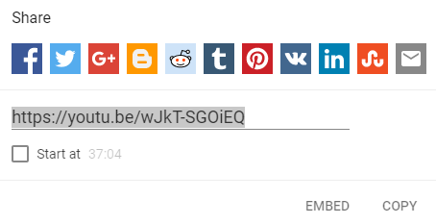

How does content go viral? It happens when people share it with their friends and their network on various social media platforms.

Therefore, platforms like Facebook, Twitter, Instagram, Snapchat etc, are great mediums for ensuring that your content reaches a wider number of people. Shared links to your [YouTube](https://ythunder.com/) video on social media will help drive a greater number of views on your content.

* **Use influencers effectively**

This point should be combined with the earlier one about leveraging social media. Influencers are people who enjoy an extensive network and have a lot of followers on social media.

Therefore, when these influencers share your content, it ends up reaching a huge number of people. Using influencers effectively can help ensure a greater number of views on your [YouTube](https://ythunder.com/) video.

* **Collaborate with other successful** [**YouTuber**](https://ythunder.com/)**s**

Sometimes the best way to boost [YouTube views](https://ythunder.com/) is by combining audiences across multiple videos. This can be achieved by collaborating together with another successful [YouTuber](https://ythunder.com/)s in creating your videos.

It’s a win-win situation because it brings together your engaging content along with another [YouTuber](https://ythunder.com/)’s popularity which helps both of you in driving up views.

* **Use closed captions for your videos**

[YouTube](https://ythunder.com/)’s algorithm has evolved so much that it can now listen to the content of your videos. This can be seen by the “closed captions” button at the bottom of the screen which shows auto-generated subtitles. Adding subtitles to your video, therefore, greatly improves its ranking in [YouTube](https://ythunder.com/)’s search engine. This is because subtitles make your video accessible and improve the experience of the viewer.

Therefore, adding closed captions can help boost your [YouTube](https://ythunder.com/) SEO leading to greater views.

* **Add an end-slide appeal**

It is always a good idea to end your video with a little slide that reminds audiences to share your content and to subscribe to your channel. Often, people might have loved your video but forget to share it and just move on to the next video. Therefore, reminding them to share your video will help you reach a greater size of the audience.

Moreover, asking viewers to subscribe to your channel ensures that you have a captive audience which will view any new video that you upload.

* **Try to get some earned media**

The best videos are those which get talked about by people. If your video is funny, topical, or extremely informative, chances are that a blogger or an online community will write about it.

These third-party referrals end up driving a huge amount of audience traffic to your [YouTube](https://ythunder.com/) video. It is, therefore, very important to make a video that instantly hits a chord with influential people in your audience.

For example: if you make a video talking about 5 unique eating places in your town, it is very likely to get featured on a travel blog. This helps in boosting your [YouTube views](https://ythunder.com/) greatly.

* **Longer videos and user engagement**

[YouTube](https://ythunder.com/)’s algorithm uses the length of your video as a sign of user engagement. The average duration of a top-ranked [YouTube](https://ythunder.com/) video is about 14-15 mins. Therefore, ensure that your video is long enough to keep your audience engrossed and engaged.

Moreover, adding a call to action that allows viewers to engage with your content (e.g. leaving a comment) greatly contributes to improving your video’s [YouTube](https://ythunder.com/) search ranking which leads to greater views.

Overall, the most important thing to remember is that your video must be extremely engaging and interesting.

With that, these simple guidelines will definitely help you increase the number of views on your [YouTube](https://ythunder.com/) video.



Free Youtube views for an unlimited number of your videos! Boost your video's popularity using their simple and free method! Or, buy Youtube views and other services here.

[ythunder.com](https://ythunder.com/) has free & open registrations.